Texas Hold’em Poker

User Manual

Installation 3

Start Screen 4

How to play 5

User Interface Elements 7

Menu Options 9

# Installation

Installation: Copy the folder to your pc, and double click on the index.hml file to open it



# System Requirements

Minimum System Requirements: Most modern browsers – recommended to use Firefox on Mac OS for performance gains.

# Start Screen

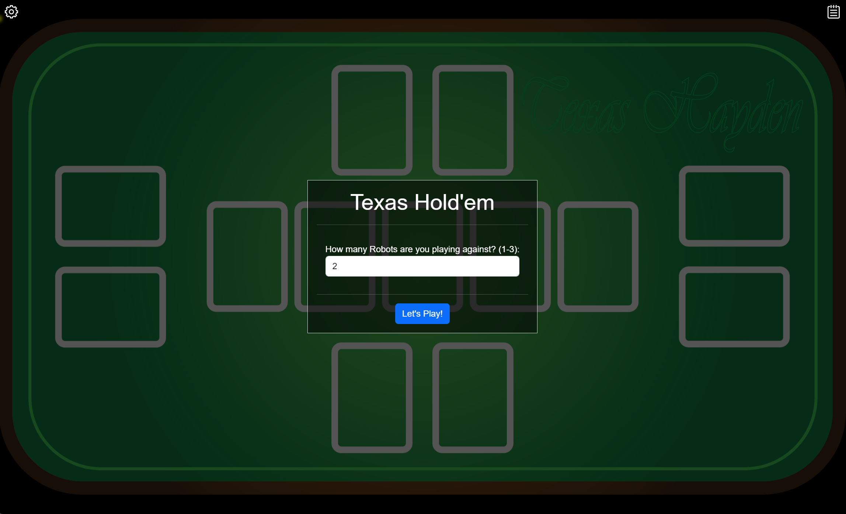

From the start screen, choose the number of Robot opponents, then click “Lets Play!” to start the game.

# How to play

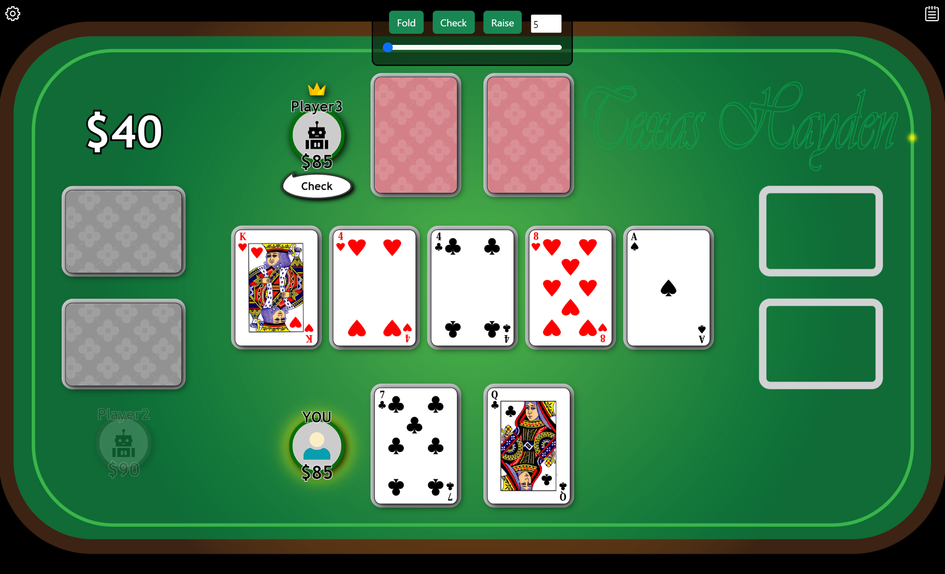

**The following outlines a Texas Hold’em round:**

1. System will assign a Dealer (either randomly if first game, or by rotating clockwise from last dealer)
2. Blind bets are made (small and big blind)
3. Pre-float cards are dealt (2 to each player – Computer players are dealt face down)
4. Pre-float betting occurs
5. Float cards are dealt (3 cards face up in the community hand)
6. Float betting occurs
7. Turn card is dealt (1 card face up in the community hand)
8. Turn betting occurs
9. River card is dealt (1 card face up to complete the community hands)
10. River (and final) betting occurs
11. Showdown – the system will determine the best hand and award money to the appropriate player(s)
12. If there are still players left, and the human player still has money, a new round will commence
13. If the human player has no money the game is over as lost.
14. If there are no computer players with money, the game is over as won.

Standard Texas Hold’em Rules apply

For an example see: <https://howtoplaypokerinfo.com/poker-101/texas-holdem-rules>

The following exceptions apply:

* Big blind is considered the first bet to call, the small blind player will need to match it too in the pre-flop betting round
* In 2 player games, the small blind and big blind are rotated through the players as per games with more than 2 players
* A raise can be any amount above the minimum bet amount (plus Call amount) and under the maximum bet
* No additional pot(s) are created when a player goes all-in. The player could win the entire pot.
* All-in will occur if big blind or small blind cannot be made

# User Interface Elements

|  |  |
| --- | --- |
|  | |
|  | Pot – Shows the current balance in the Pot |
|  | Player folded – Greyed out elements indicate a player that has folded |
|  | Player Options – From here the various hand options are available:  **Fold**: Fold this hand  **Check**: If valid, player can check.  **Call**: If valid, player can Call  **Raise**: Raise the current bet  **All-in:** If money is low, All-in option will be shown  **Raise Slider:** The amount to raise can be increased using the slider.  Call button will show the current amount required to call.  Raise amount is added onto the required amount for a call. So a raise of $20 when it is $10 to call, will result in a total bet of $30 being made. |
|  | Player hand – Shows the current player balance and cards |
|  | Community Hand – Shows the community hand |
|  | Empty Slot – No player is in this slot |
|  | Action Bubble: Shows the last action a computer player has made |
|  | Dealer badge – Shown for the player allocated as dealer |

# Menu Options

|  |  |
| --- | --- |
|  | |
|  | **Options Menu**  **New Game:** Starts a new game  **Music Enabled:** Enables/Disables background music.  **Starting Money:** Specifies the money each player will start with.  **Minimum Bet:** Specifies the minimum bet (raise) that can be made.  **Show Player Cards:** If enabled, the computer player cards will be shown.  **Disable Animations:** On slower systems the animations can be disabled to increase performance.  **Attributions:** Outlines the source of music and sound effects used in this software |
|  | **Play Log**  Shows a log of player actions throughout the game |